Embedding Spaces in Multimodal AI

Goal of this Module
The goal here is to demystify how multimodal AI represents and compares different types of data (text, images, audio, etc.) in a unified way. By understanding embedding spaces, cosine similarity, contrastive training, cross-modal alignment, and fusion strategies, you'll be able to:
- Grasp why "similar meaning" works across modalities
- See how models like CLIP, ImageBind, or LLaVA achieve zero-shot cross-modal understanding
- Choose the right fusion approach when designing or debugging multimodal systems
- Recognize the core mechanism behind semantic search, recommendation, and generation in modern AI
This module builds the foundation for why multimodal AI feels intelligent, it's all about getting different data types to speak the same language in a shared mathematical space.
Imagine you have a huge, invisible room (high-dimensional space, but don't worry about the number of dimensions right now).
Every meaningful thing — a word, a sentence, a photo of a sunset, a song clip — gets turned into a single point floating somewhere in this room.
The closer two points are, the more similar their meanings are.
That's an embedding space.
Now, how do we actually measure "close"?
The most popular way is cosine similarity.
Think of it like this: forget the actual distance between two friends standing in a park. Instead, look at the direction they're facing. If both are pointing toward the same beautiful view, they're aligned — even if one is 2 meters away and the other is 200 meters. Cosine cares about angle, not distance.
- Angle = 0° → cosine = 1.0 → perfectly the same meaning
- Angle = 90° → cosine = 0 → no relation at all
- Angle = 180° → cosine = -1 → opposites
Most modern systems use dot product (which is basically cosine when vectors are normalized to length 1). It's super fast on GPUs.
And sometimes we add a little temperature knob (a number like 0.07 or 0.1). Lower temperature makes the model more "decisive" — big similarities become huge, small ones become tiny. It's like turning up the contrast on a photo.

Real-life feel:
- Search "cozy mountain cabin at night" → the system finds images whose embedding points are very close (small angle) to your text embedding.
- Recommend songs → your past likes cluster in one cozy corner of the space; new suggestions come from nearby.
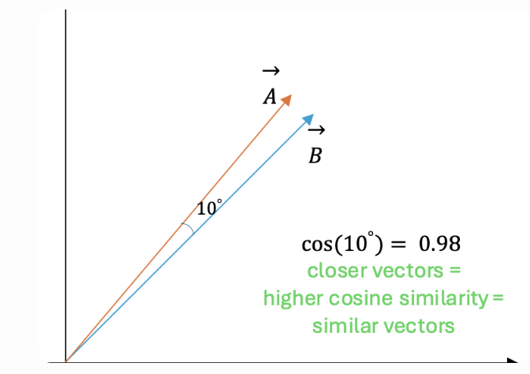

Contrastive Learning
Now the really clever part: how do we actually move those points around so good matches end up close?
We use contrastive learning — and the most famous loss function is InfoNCE (Noise-Contrastive Estimation).
Intuition in simple words:
Imagine you're teaching a child what a "puppy" is.
You show one real photo of a fluffy golden retriever (positive example).
Then you show 100 other random photos: cats, cars, trees, a wolf, etc. (negatives).
You tell the child:
"Pull the golden retriever photo super close to the word 'puppy'.
Push all the others far away."
Do this millions of times → eventually the model learns that "puppy" should live near fluffy dog images and far from everything else.
InfoNCE is exactly that idea in math form:
It looks at one positive pair and many negative pairs in a batch, computes similarities, turns them into probabilities with softmax + temperature, and says:
"Make the probability of picking the correct positive one as high as possible."

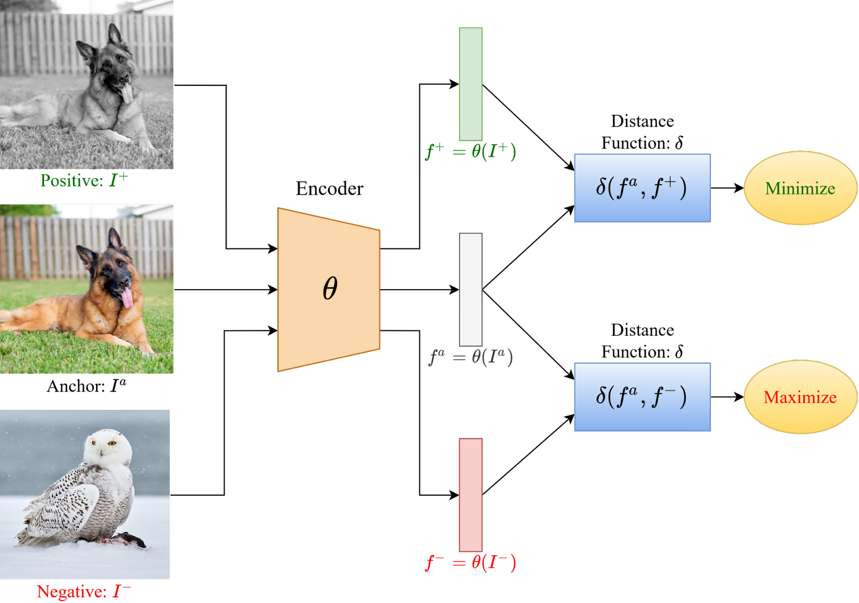

Cross-Modal Alignment
one shared embedding space where "a cat sitting on a windowsill" (text) is right next to the actual photo of that scene.
We train two separate encoders:
- Image encoder (ViT, ConvNeXt, etc.) → turns pixels → vector
- Text encoder (transformer) → turns words → vector
Then we project both into the same dimension and train contrastively so matched pairs attract, unmatched repel.
Real examples:
- You type "vintage bicycle leaning against a brick wall at golden hour" → finds stock photos that match the vibe.
- Reverse image search but smarter: upload photo of unknown plant → gets scientific name + care instructions.
- E-commerce: upload selfie in outfit → finds "similar style" products.
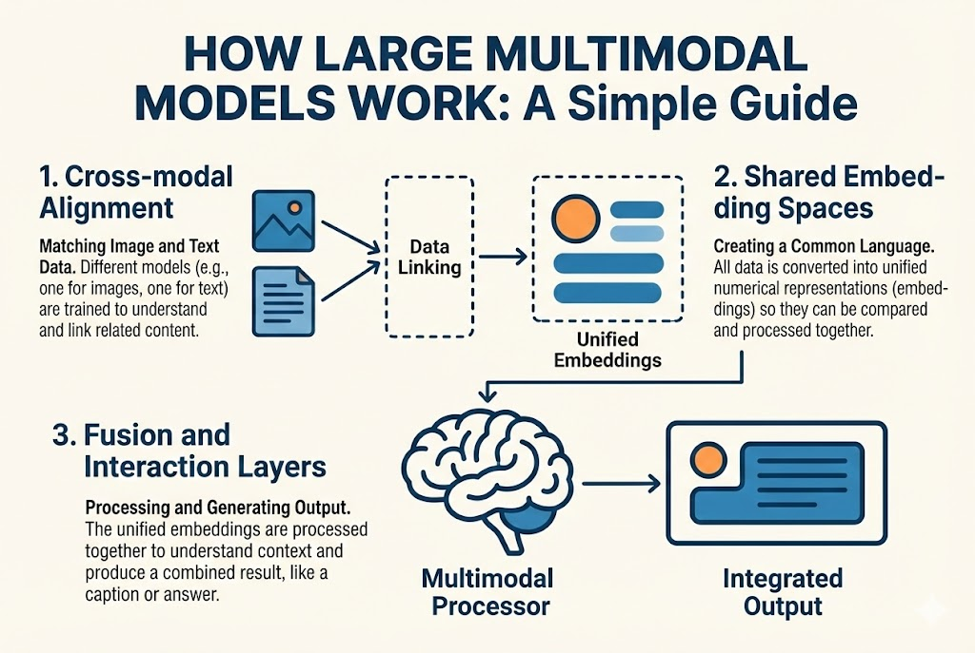

Late vs Early vs Hybrid Fusion – When & Where to Mix Modalities
Okay, now the big architectural choice.
- Early fusion: mash raw data together at the very beginning (pixel + audio waveform concatenated somehow). Very powerful when modalities are tightly coupled (like video = image frames + sound). But noisy — one bad modality poisons everything.
- Late fusion: run each modality through its own powerful model separately → get final predictions or embeddings → combine at the end (average, weighted vote, small MLP). Very flexible, easy to train separately, robust when one sensor fails. But misses deep interactions.
- Hybrid fusion (most modern sweet spot): some early/intermediate mixing + some late decisions. For example → image goes through ViT → text through LLM → then cross-attention layers let text "look at" image regions deeply → finally generate answers.

Quick rule of thumb I use:
- Simple search/retrieval → unified embedding space (late/contrastive) is often enough (CLIP-style)
- Complex reasoning, fine details, "why is this happening in the video?" → you need cross-attention (hybrid). Text tokens get to attend to different parts of the image.
Cross-attention in action (this is what makes models like GPT-4o, Gemini, LLaVA feel so smart):
The language model doesn't just get a single vector summary, it gets to dynamically "look" at different parts of the image/audio while generating each token.

Conclusion & Key Takeaways for Embedding & Fusion
Embedding spaces are the invisible backbone of multimodal AI, turning wildly different data into comparable points in a shared universe.
Key Takeaways
- Embeddings + cosine similarity = universal similarity measure across modalities
- Contrastive learning (InfoNCE) teaches "what belongs together" without expensive labels
- Cross-modal alignment (CLIP-style) enables zero-shot retrieval and understanding
- Fusion strategy matters: Early = deep but brittle; Late = robust but shallow; Hybrid = best of both (current leader)
- Cross-attention is the secret sauce for fine-grained, reasoning-heavy multimodal tasks
Master these concepts and you'll understand 90% of why today's multimodal models (2026 era) work so well, and where the next breakthroughs will come from. This shared-space thinking is what turns isolated unimodal AIs into truly world-understanding system

